🛡️ SOC Home Lab
Build, Configure & Threat Detection
Salman Mohammed AL Mayasi | June 2026

Author | Salman Mohammed AL Mayasi
Role | Blue Team / SOC Analyst (Learner)
Date | June 2026
Lab Type | Home SOC Lab — Threat Detection
Virtualization | VMware Workstation + VirtualBox
Network Mode | Bridged — 192.168.0.0/24

Table of Contents
Scenario 3
Executive Summary 4
2. Lab Architecture & Environment 4
2.1 Network Topology 4
2.2 Tools Installed 4
3. Lab Setup & Configuration 5
3.1 Windows 11 Pro — Target Machine 5
3.2 Sysmon — Endpoint Monitoring 5
3.3 Velociraptor — DFIR Platform 6
3.4 Ubuntu & Kali — Supporting Machines 7
4. Hunt 1 — User Account Discovery (Windows.Sys.Users) 8
4.1 Objective 8
4.2 Hunt Configuration 8
4.3 Findings 10
5. Hunt 2 — Network Connection Monitoring (Windows.Network.Netstat) 10
5.1 Objective 10
5.2 Nmap Scan from Kali 10
5.3 Hunt Results 11
5.4 Key Observations 11
6. Lessons Learned 12
6.1 Technical Findings 12
6.2 Detection Gaps Identified 12
6.3 Next Steps 12
7. Indicators of Compromise (Lab IOCs) 12
8. Conclusion 13

Scenario: On the evening of June 23, 2026, the SOC analyst at the lab environment detected unusual network activity on the Windows 11 workstation (SOC_LAB — 192.168.0.101). A reconnaissance scan was initiated from an external Kali Linux machine (192.168.0.106) targeting the internal Windows endpoint across all 1000 TCP ports.
The attacker's goal was to map open services and identify potential entry points on the target machine. Although the Windows Defender Firewall successfully filtered all inbound scan packets — returning no open ports to the attacker — the endpoint monitoring stack told a different story. Velociraptor's Network.Netstat artifact, collected in real time during the scan window, revealed Port 139 (NetBIOS) in a LISTEN state, confirming that the scan had reached the host's network stack despite being blocked at the firewall layer.
This scenario demonstrates a core Blue Team principle: network-level blocking does not equal invisibility. The goal of this exercise was to detect, document, and correlate reconnaissance activity using endpoint forensics tools including Velociraptor v0.76.1 and Sysmon, without relying on perimeter alerts alone.

Executive Summary
This report documents the design, build, and initial threat detection exercises performed in a self-built SOC Home Lab environment. The lab consists of three virtual machines running in Bridged network mode, simulating a real enterprise monitoring scenario.
The lab successfully demonstrated endpoint monitoring using Velociraptor and Sysmon, network-level scanning detection using Nmap from Kali Linux, and user account enumeration via Velociraptor Hunts — all core skills required for a Blue Team / SOC Analyst role.

2. Lab Architecture & Environment

2.1 Network Topology
All virtual machines operate on a Bridged network (192.168.0.0/24), enabling direct communication as if they were physical machines on the same LAN.
VM | OS | IP Address | Role
Windows 11 Pro | Windows 11 Pro 25H2 | 192.168.0.101 | Target + Velociraptor Server
Ubuntu | Ubuntu Linux | 192.168.0.109 | Monitoring / Client
Kali Linux | Kali Linux 2026.1 | 192.168.0.106 | Attacker Simulation

2.2 Tools Installed
Tool | Version | Purpose
Velociraptor | v0.76.1 | DFIR Platform — Server + Client on Windows
Sysmon | Latest | Endpoint Process & Network Logging
Nmap | Latest | Network Scanning from Kali (Attack Simulation)
VMware Workstation | 17 Player | Windows 11 Virtualization
VirtualBox | Latest | Ubuntu & Kali Virtualization

3. Lab Setup & Configuration

3.1 Windows 11 Pro — Target Machine
The Windows 11 Pro VM serves as the primary monitored endpoint. Both Velociraptor Server and Sysmon are installed on this machine.
OS: Microsoft Windows 11 Pro 25H2 (Build 10.0.26200.8655)
IPv4 Address: 192.168.0.101 / Subnet: 255.255.255.0
Default Gateway: 192.168.0.1
User Account: sq242 (UID 1001)
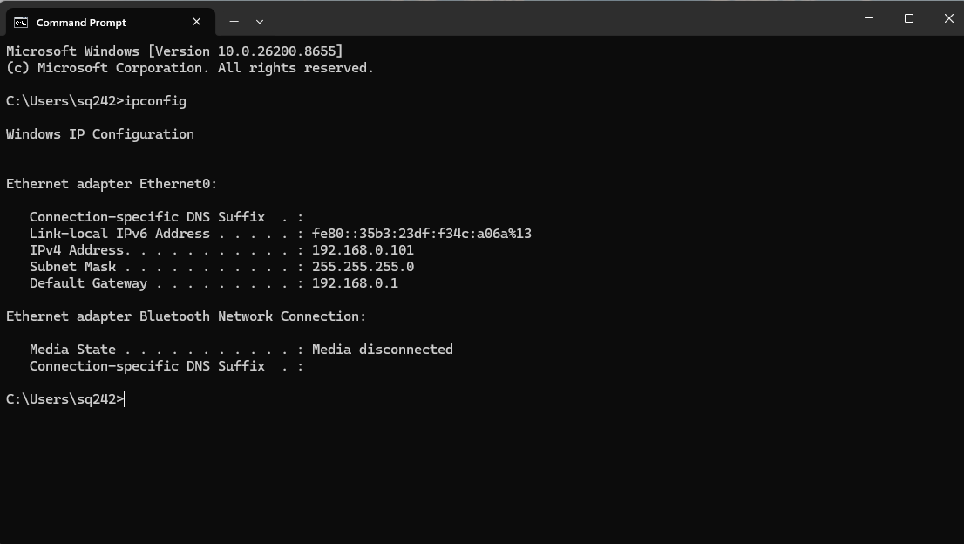
Figure 1: ipconfig output showing 192.168.0.101

3.2 Sysmon — Endpoint Monitoring
Sysmon (System Monitor) was installed and verified as running on the Windows 11 machine. Sysmon logs detailed endpoint activity including process creation, network connections, and file operations.
- Service Status: Running
- Verification Command: Get-Service Sysmon

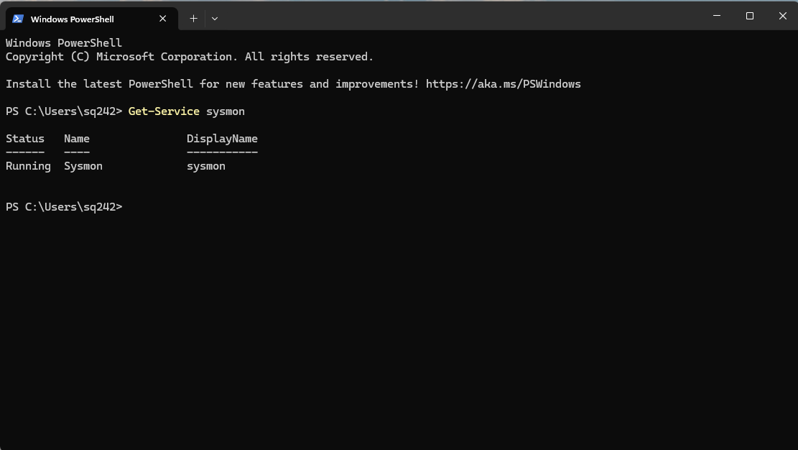
Figure 2:PowerShell showing Sysmon Running

3.3 Velociraptor — DFIR Platform
Velociraptor v0.76.1 was installed and configured as both Server and Client on the Windows 11 machine. The web interface is accessible at https://192.168.0.101:8889.
Server URL: https://192.168.0.101:8889
Admin User: admin <root>
Connected Clients: 2 (SOC_LAB + Ubuntu)
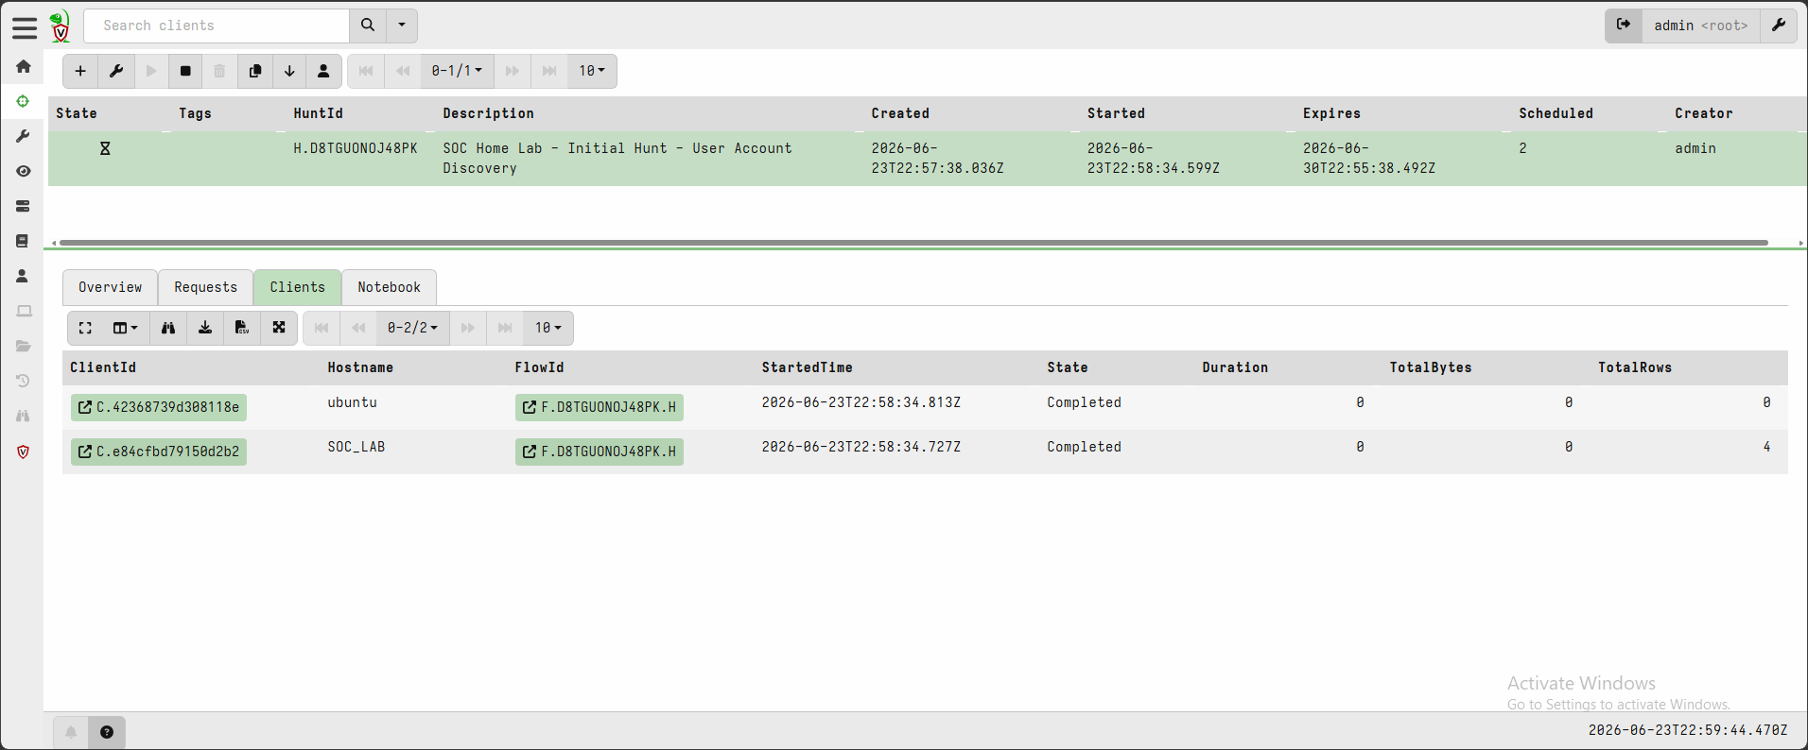
Figure 3:Velociraptor Dashboard showing connected clients

3.4 Ubuntu & Kali — Supporting Machines
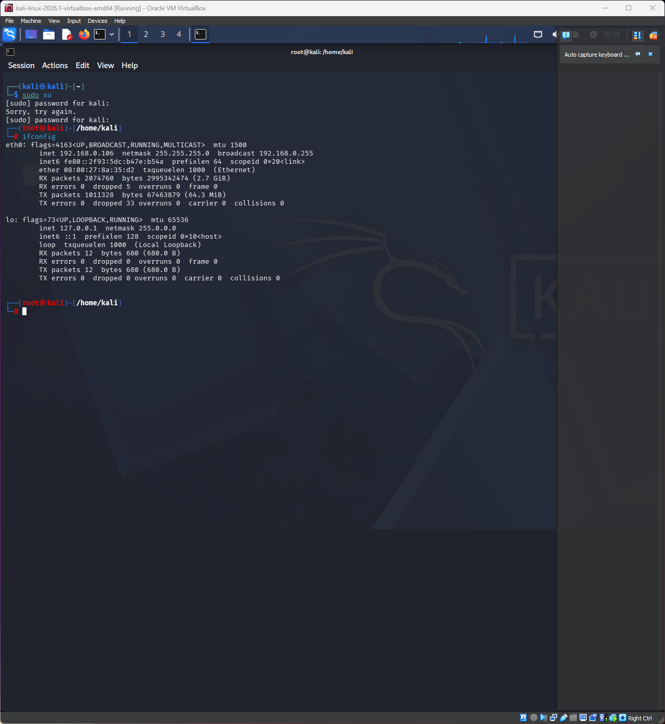
Ubuntu (192.168.0.109) acts as a secondary monitored client, while Kali Linux (192.168.0.106) serves as the attacker simulation platform.
Figure 4:Kali ifconfig showing 192.168.0.106
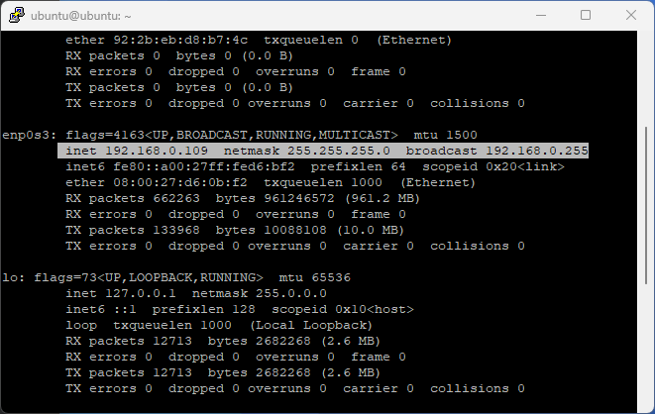

Figure 5: Ubuntu ifconfig showing 192.168.0.109

4. Hunt 1 — User Account Discovery (Windows.Sys.Users)

4.1 Objective
Enumerate all local user accounts on the Windows 11 target machine using Velociraptor's Windows.Sys.Users artifact. This simulates a Blue Team analyst checking for unauthorized accounts after a suspected compromise.

4.2 Hunt Configuration
Parameter | Value
Hunt ID | H.D8TGUONOJ48PK
Description | SOC Home Lab - Initial Hunt - User Account Discovery
Artifact | Windows.Sys.Users
Target | SOC_LAB (Windows 11 Pro)
Start Time | 2026-06-23T22:58:34.599Z
Duration | 0.61 seconds
Total Rows | 4
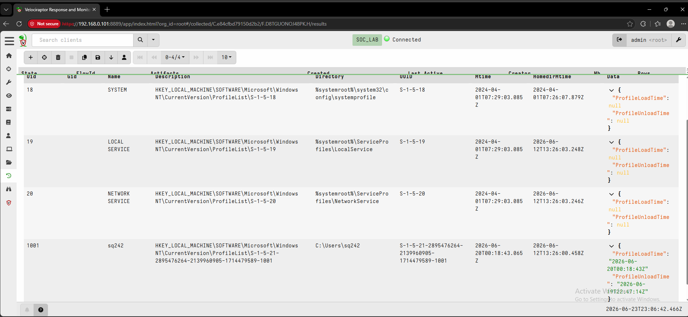
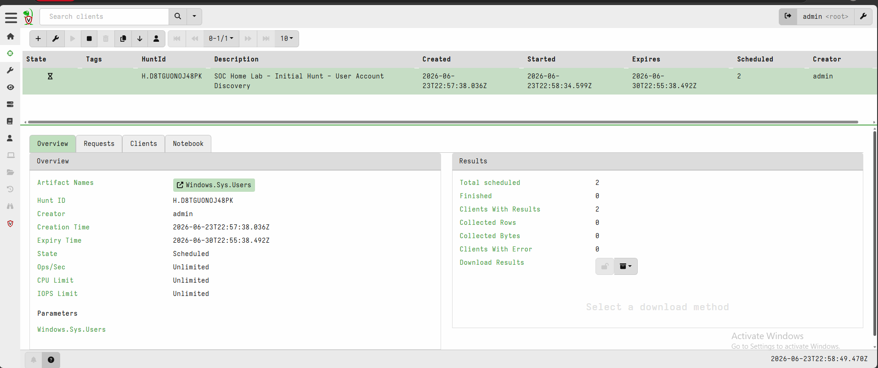
Figure 6: Hunt Results showing 4 rows
Figure 7:Velociraptor Hunt Manager — Windows.Sys.Users Hunt Created

4.3 Findings
Velociraptor successfully enumerated 4 accounts on the Windows 11 target:
UID | Name | Type | Home Directory
18 | SYSTEM | System Account | %systemroot%\system32\config\systemprofile
19 | LOCAL SERVICE | Service Account | %systemroot%\ServiceProfiles\LocalService
20 | NETWORK SERVICE | Service Account | %systemroot%\ServiceProfiles\NetworkService
1001 | sq242 | Real User Account | C:\Users\sq242

The user sq242 (UID 1001) is the primary interactive user on the system. The three service accounts (SYSTEM, LOCAL SERVICE, NETWORK SERVICE) are standard Windows system accounts.

5. Hunt 2 — Network Connection Monitoring (Windows.Network.Netstat)

5.1 Objective
Capture all active network connections on the Windows 11 machine using the Windows.Network.Netstat artifact. This hunt was performed during and after an Nmap scan from Kali Linux to detect scanning activity.

5.2 Nmap Scan from Kali
An Nmap scan was initiated from Kali Linux (192.168.0.106) targeting the Windows 11 machine (192.168.0.101) to simulate reconnaissance activity:
nmap -sV 192.168.0.101
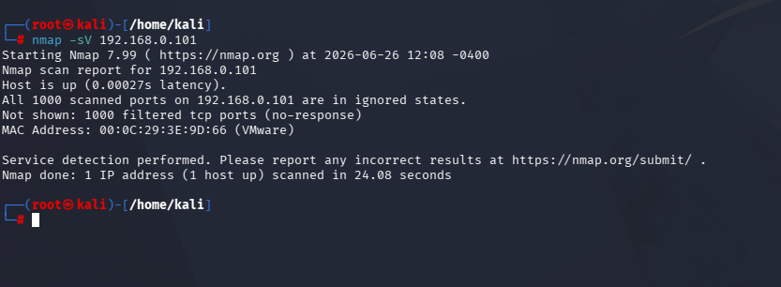
Figure 8: Kali Nmap scan results showing open ports on 192.168.0.101

5.3 Hunt Results
Parameter | Value
Artifact | Windows.Network.Netstat
Total Rows Captured | 75
Key Finding | Port 139 (LISTEN) — triggered by Nmap scan
Velociraptor Connection | 192.168.0.101:8000 ↔ 192.168.0.109:53208

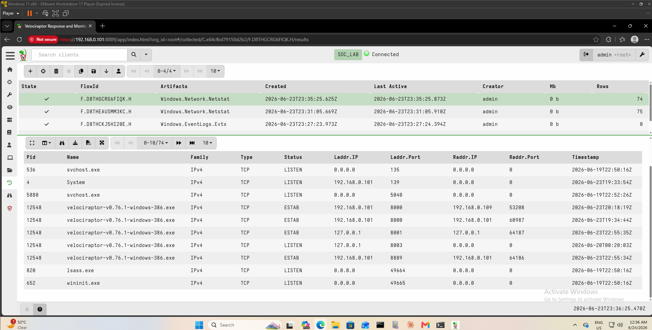
Figure 9: Velociraptor Netstat results showing 74 rows with port 139

5.4 Key Observations
- Port 139 (NetBIOS) appeared in LISTEN state — consistent with Nmap scan probing
- Velociraptor agent maintained connection to server during the scan (ESTAB)
- msedge.exe showed external HTTPS connections (port 443) — normal browser traffic
- lsass.exe listening on port 49664 — standard Windows authentication service
- No direct connection from 192.168.0.106 (Kali) captured — Nmap scan completed before Hunt collection window

6. Lessons Learned

6.1 Technical Findings
- Velociraptor Hunts provide powerful on-demand forensic collection from endpoints
- Netstat artifact is most effective when triggered immediately during a scan
- Sysmon complements Velociraptor by providing real-time event logging (Event ID 3 for network connections)
- Bridged network mode enables realistic multi-VM attack/defend scenarios

6.2 Detection Gaps Identified
- Nmap scan timing: Hunt must be launched during the scan to capture source IP
- Sysmon Event ID 3 rule needed to log SMTP/scanning connections automatically
- No SIEM integration yet — logs are only visible in Velociraptor UI

6.3 Next Steps
- Integrate Elastic SIEM or Splunk for centralized log analysis
- Configure Sysmon with comprehensive ruleset (SwiftOnSecurity config)
- Add Active Attack Scenario: simulate credential dumping and detect with Velociraptor
- Deploy Suricata on Ubuntu for network-level IDS detection

7. Indicators of Compromise (Lab IOCs)

Type | Value | Context
IP — Scanner | 192.168.0.106 | Kali Linux — Nmap source
IP — Target | 192.168.0.101 | Windows 11 — Monitored endpoint
Port | 139 (NetBIOS) | Port triggered by Nmap scan
User Account | sq242 (UID 1001) | Primary user on target system
Process | velociraptor-v0.76.1 | DFIR agent — legitimate

8. Conclusion

This SOC Home Lab demonstrates a functional Blue Team monitoring environment built from scratch using enterprise-grade open-source tools. The lab successfully validated:

Multi-VM network connectivity in Bridged mode

Velociraptor deployment as a DFIR platform with live client connections

Endpoint monitoring via Sysmon

User account discovery via Velociraptor Hunt (Windows.Sys.Users)

Network connection monitoring via Hunt (Windows.Network.Netstat)

Attack simulation using Nmap from Ka

